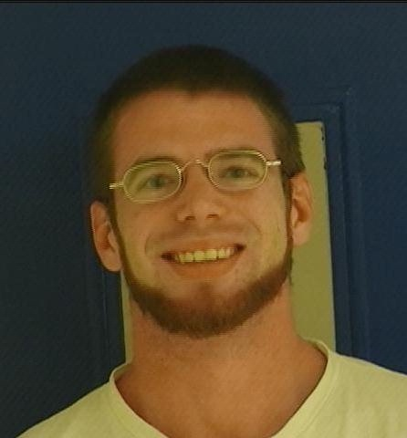 | 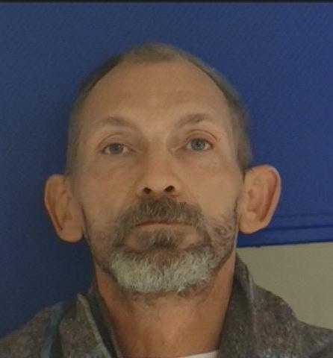 | 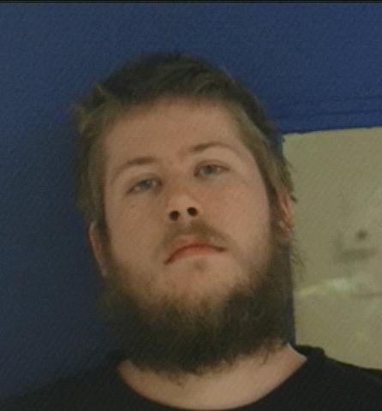 | 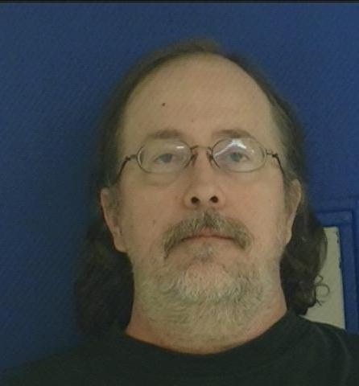
JOSEPH FOSDICK | BRET PHILLIPS | MICAH SHAEFER | FRANK CAMPBELL
Los Molinos, Ca | Red Bluff, Ca | Montgomery Creek, Ca | Montgomery Creek, Ca
Possession of marijuana for sale | Possession of marijuana for sale | Possession of marijuana for sale | Possession of marijuana for sale
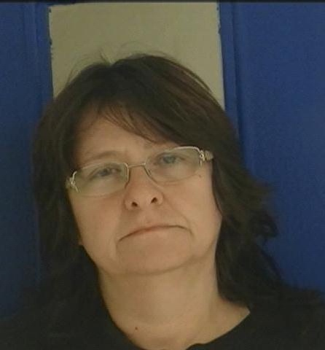 | 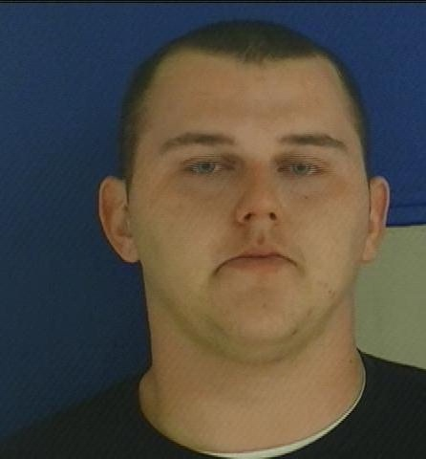 | 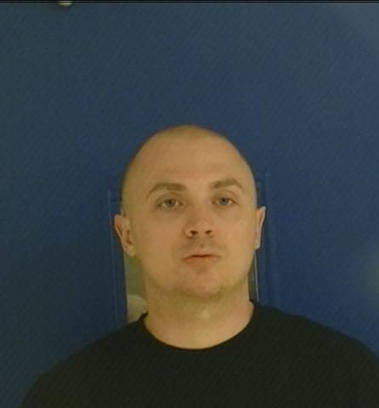 | 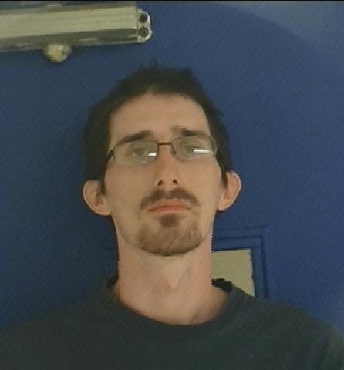
MARY ASHLOCK | TERRENCE PIRRITANO-GREEN | JESSE SMITH | WILLIAM RICHTER
Red Bluff, Ca | Cottonwood, Ca | Santa Cruz, Ca | Anderson, Ca
Possession of marijuana for sale | Possession of marijuana for sale | Attempt / Possession of marijuana for sale | Possession of controlled substances for sale
 | 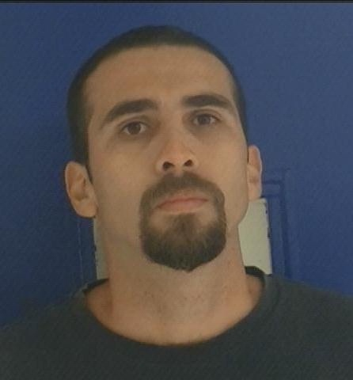 | 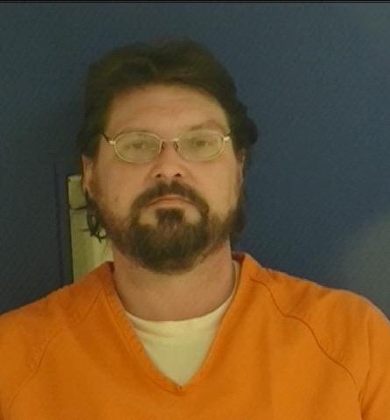 | 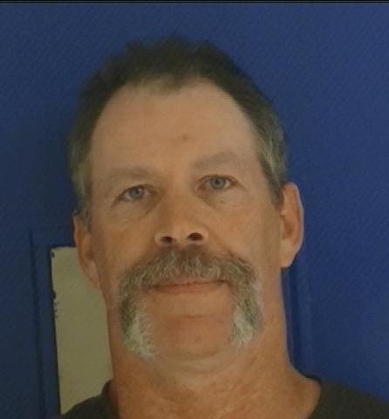
DONNA MOORE | MARCOS NUNEZ | JOSHUA TANNER | SCOTT ELLIOTT
Corning, Ca | Corning, Ca | Red Bluff, Ca | Oak Run, Ca
Possession of marijuana for sale | Possession of marijuana for sale | Meet minor for sex | Meet minor for sex  Possession of marijuana for sale
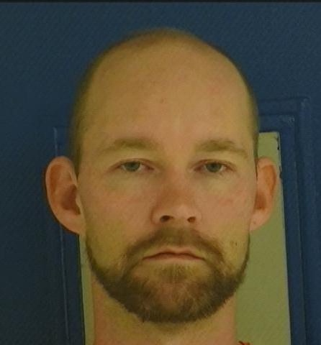 | 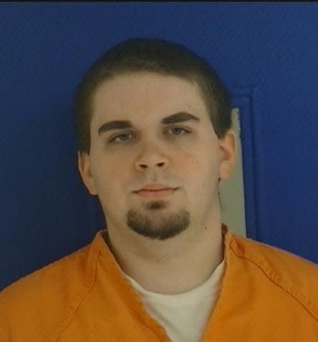 | 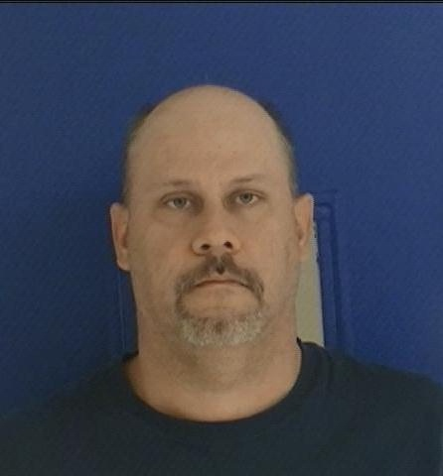 | 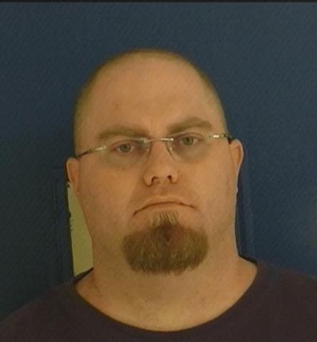
OCEAN LITTLEFIELD | RYAN LAMERRILL | CARL HOOKER | CHAD QUINNELL
Red Bluff | Red Bluff, Ca | Corning, Ca | Chico, Ca
Meet minor for sex | Meet minor for sex | Meet minor for sex | Meet minor for sex
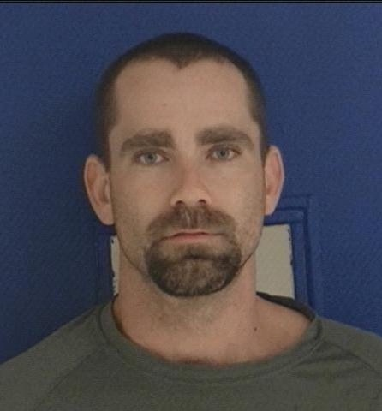 | 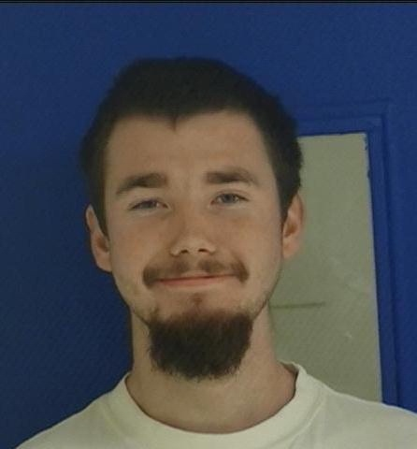 | 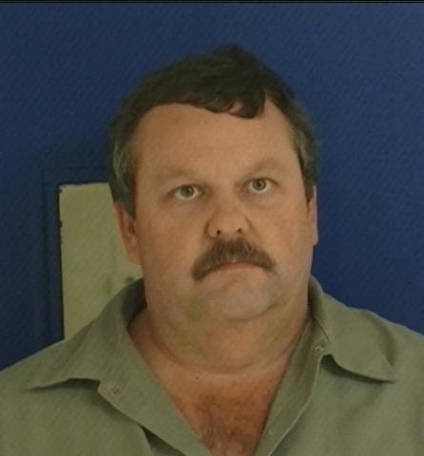 | 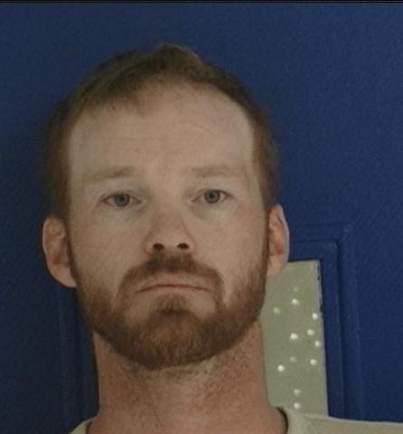
TIMOTHY BROWN | ERICK DAVIS | THADDEUS DUCKWORTH | SANULE SKILLEN
Redding, Ca | Cottonwood, Ca | Los Molinos, Ca | Red Bluff, Ca
Possession of controlled substances for sale | Possession of dangerous weapon | Meet minor for sex | Meet minor for sex
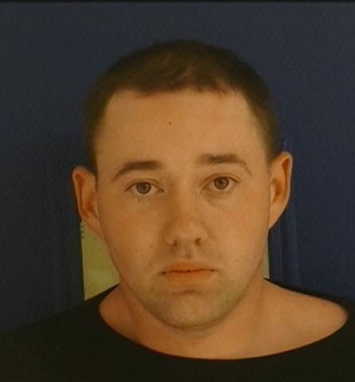 | 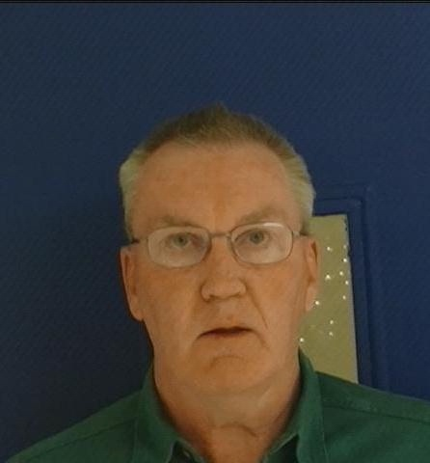 |  | 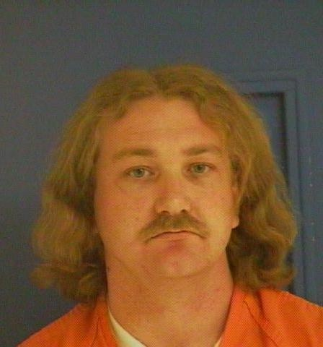
SCOTT REID | GREGG HARMON | JUVENILE FEMALE | ANDREW COFFEE
Red Bluff, Ca | Red Bluff, Ca | Red Bluff, Ca | Red Bluff, Ca
Meet minor for sex | Meet minor for sex | Solicitation for prostitution | Solicitation for prostitution
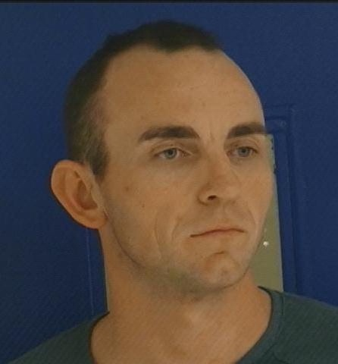 | 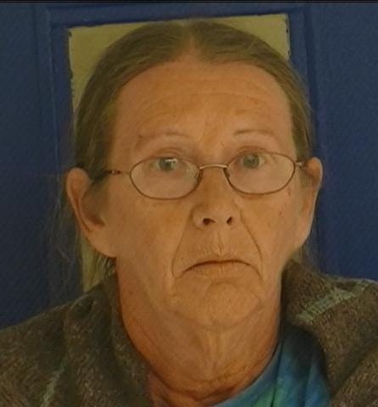
JAMIE HALTER | ARLITA WYMAN
Redding, Ca | Red Bluff, Ca
Meet minor for sex | Possession of marijuana for sale

